Emrys Huntington Karmijn Kunstenaarscollectief Expo Boezemstraat 187

Walks and Digital introspections during Isolation Revisited
(acrylic paint and/or markers on wood)
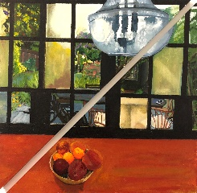 Recaptcha (2017) 62x62cm €835
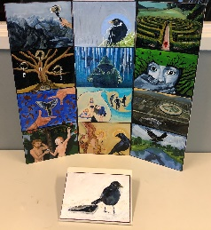 13 Ways of Looking at an iBird (2018)` 72x68cm €1065
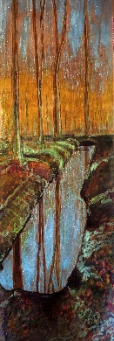 Walk past Parallel Woodland Moats (2020) 24x68cm €360
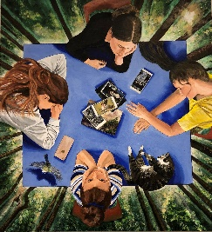 Tablets Turned (2021) 90x100cm €1955
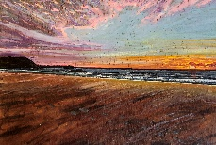 Walk Parallel to the Shore 27x18cm €110
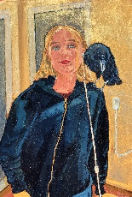 And What Spoke That Strange Silence
After His Clamour of Caws Faded? 18x24.5ccm €100
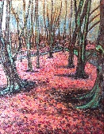 Walk by way of a Wood (2021) 19x24.5cm €105
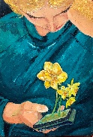 They Flash Upon That Inward Eye (2021) 17x24cm €100
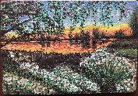 Walk at Day’s End (2021) 25x17.5cm €100
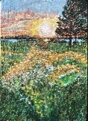 Walk through Wildflowers (2021) 17.5x24.5cm €100
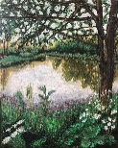 A Walk Pausing at a Pond under Blossoms (2021) 19x24cm €100
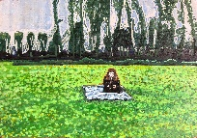 Pause during a Walk in Field of Grass (2021) 25x17.5cm €100
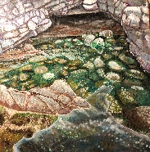 Walk Circumnavigating Tidal Pool (2021) 30x30cm €200
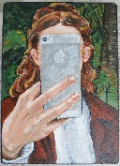 Selfie of a Lady (2019) 17x24cm €100
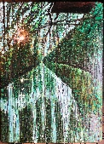 Walk over Waterway under Willows (2021) 22x29.5cm €142
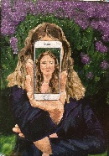 Portrait of a Lady, part II, (2019)
“And Smiles at Situations Which It Cannot See” 17x24cm €100

